Security Enhancements Using Routers and Switches

Table of Contents
1. Abstract
2. Introduction | 3
3. Existing System | 4
4. Proposed System | 5
5. system Requirements | 6

Abstract
Companies that have multiple offices need a cost-effective, efficient means to exchange data between those offices. Many companies have created intranets or extranets, which enable users at different locations to view, upload, and download information. However, intranets and extranets are only a partial solution to the problem because the sharing of data is limited to what can be posted on the intranet or extranet. Each office must maintain its own database, and users cannot access data stored at other locations. For example, the accounting department at each office must have a separate database, which cannot be shared over an intranet.

Security is also an issue because the intranet must be connected to the Internet, in order to serve multiple locations. To avoid theses type limits we can Wide Area Technologies (WAN), with in the compus we can use Local Area Connection (LAN)
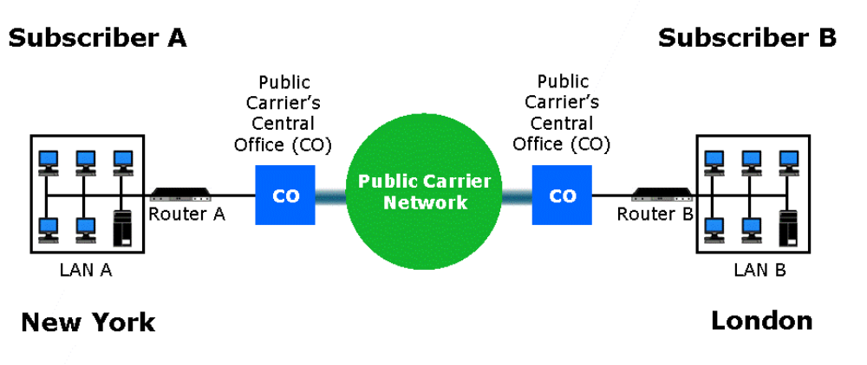
The Routers and Switches are used to implement WAN and LAN technologies, The IOS (internetworking Operating System) used implement secure technologies in routers and switches.
Introduction
Routers and Switches are the basic building blocks of networking.
Routers are Layer 3 devices and switches are Layer 2 devices.
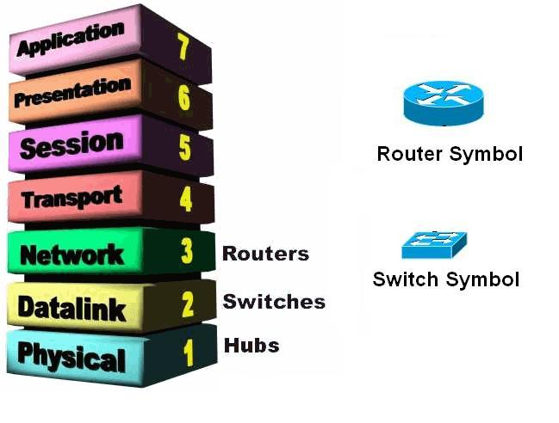

Router
Routers are internetworking devices that operate at the Network Layer (Layer 3) of the OSI model. Using a combination of hardware and software (Cisco Routers use the Cisco IOS—Internet work Operating System), routers are used to connect networks. These networks can be Ethernet, Token Ring, or FDDI—all that is needed to connect these different network architectures is the appropriate interface on the router.

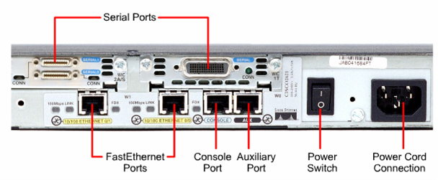

Fig: The Rear View of Cisco 2500 Series router.

Router configuration Sources
- Routers can be configured from:
Console terminal
Auxiliary port – externally, via modems
Virtual terminals (Telnet) – after installation
Downloading from a TFTP server

Internal Configuration Compoents
- RAM
Contains dynamic / running configuration
- NVRAM
Contains backup of configuration (startup configuration)
- Flash
Contains copy of Cisco IOS
- ROM
Contains a subset of IOS
Contains bootable IOS image
- Interfaces
Network connections which packets enter/exit from routers, e.g. Ethernet, serial, BRI, Token Ring
- Console and auxiliary ports
Main command-line interface used for configuration
Router Startup Sequence -- Summary
- POST
- IOS located in Flash
- IOS expanded and then loaded into RAM
- NVRAM consulted for startup configuration

Router Modes
- User EXEC mode (look, but don’t change)
Automatically enter this mode when router is turned on
You can perform basic tasks, such as connect to remote devices, perform basic tests
Prompt : Router>
- Privileged EXEC mode
High-level testing commands
Set operating parameters
Command to enter : Router>enable
Prompt : Router#
- Global configuration mode
Commands apply to features that affect the system as a whole
Enter from privileged EXEC mode with command : Router#config t
Prompt : Router(config)#
- Interface mode
Configure interface, such as Ethernet, serial
Enter from global configuration mode with command : Router(config)#int e 0/0
Or Router(config)#int s 0/0
Prompt : Router(config-if)#
- Setup mode
Helps new user to create a configuration for the first time, via a series of questions
Prompted at bootup or enter setup at router# prompt

- Rommon mode
Provides router with a small subset of IOS and helps router boot if IOS not found in Flash

Prompt : Rommon 1>

disable
User EXEC

Ctrl-Z
Privileged EXEC

Enable Ctrl-Z
Global configuration

config t
Interface

int e 0/0
int s 0/0

ROUTER STARTUP SEQUENCE – SUMMARY
1. POST
2. IOS located in Flash
3. IOS expanded and then loaded into RAM
4. NVRAM consulted for startup configuration

Switch
Switches are Layer 2 internetworking device that can be used to preserve the bandwidth on your network using segmentation. Switches are used to forward packets to a particular segment using MAC hardware addressing (the same as bridges). Because switches are hardware-based, they can actually switch packets faster than a bridge.
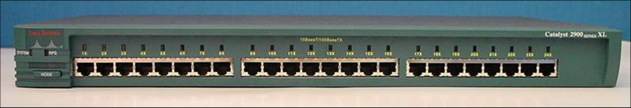
Fig: The rear view of a switch

IOS (Internetworking Operating System)
Cisco's IOS software -- an extremely powerful and complex operating system, with an equally complex configuration language. With a cryptic command-line interface and thousands of commands--some of which mean different things in different situations--it doesn't have a reputation for being user-friendly.
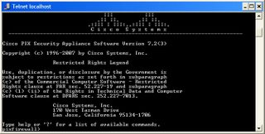

Advantages using IOS
- It is a Operating system used to manage the routers and switches
- Cisco IOS uses command line interface.
- Reliable and secure access the network and resources.
- Network scalability

Existing System
Today security is the major role in the networking, because the technology is improving day to day enormous so it is necessary to provide security to the network. The attacks are classified into different categories listed below

- Reconnaissance Attacks
- Access Attacks
- Denial of Service Attacks
- Management Protocol Attacks
- Virus, Worms and trogons Attacks

Reconnaissance Attacks
The Reconnaissance Attacks are further divided into
- Packet Sniffers
- Ping Sweeps

Packet Sniffers
Packet Sniffer is a tool by using this we can capture packets in the network, some of the tools area ethereal tool, wire shark etc.

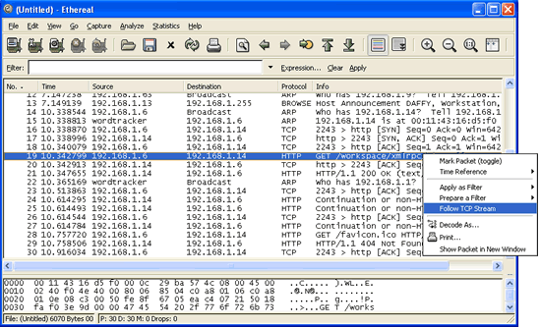
Fig: capturing the packets using ethereal tool
Packets which are send by an network
Ping Sweeps
The ping sweeps are used to identify which system is alive in the world
by using the ping command, for this purpose different tools are available in the world some of them are Angry Ping Sweeps

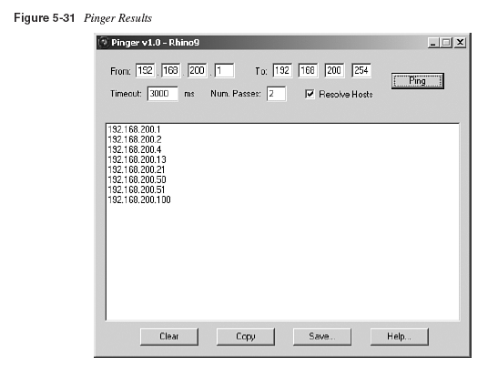

Fig: Angry Sweeps
Access Attacks
The access attacks are further divided into two categories
- Password attacks
- Man-in-the middle attacks

Password Attacks
The password attacks are done by using dictionary based attacks, brute force attacks. By using these techniques they can obtain the passwords in the network.

Man-in-the Middle Attacks
An intruder sits in the middle of the network and hacks the information and modifies the data.

Denial Of Services
Denial of Services means in a network restrict particular services in a network, DOS is further divided into 2 type
- IP Spoofing
- Distributed DOS

IP Spoofing
IP Spoofing means creation of IP Packets with forged source IP address
Distributed DOS
The DOS attack is all the devices which are attack already attacked by DOS, the systems are attacked the same server

Attacked by DOS Server

Server
Viruses, Worms and Trogon Horses
The viruses, worms and Trogon horses all are programs they can perform different tasks, they main intention is change the behavior of the system.
Viruses
Virus is a program when it open it automatically attach code to another file.
Worms
Worm is a program that replicate without infecting other programs. It is generally slowdown the processor.
Trogons
It is a program that contains code that makes the file unrecognizable.

Proposed System
The proposed system is tells how to mitigate the problems in the existing system. The mitigation techniques are listed below according above categories.

Reconnaissance Attacks
The mitigation techniques of reconnaissance attacks are listed below
- Authentication
- Anti Sniffers
- Cryptography
Access Attacks
The mitigation techniques of Access Attacks are listed below
- Eliminate duplicate passwords
- Use strong authentication
- Disable Accounts after failed authentication and cryptography.

DOS
The mitigation techniques of DOS are listed below
- Cryptography
- layered authentication
Viruses, Worms and Trogon horses
The mitigation techniques of viruses, worms and trogon horses are listed below
- Keep up to date ant viruses software.
- Isolated infected devices by using VLANS’ we can isolate the device.
- Industry awareness

Managements Protocol Attacks
The Managements protocol mitigation are listed below
- SSH (Secure Shell)
- cryptography
- VLANS’

